Java Object-Oriented Programming Experimental Report
NO: Experiment 3 Experiment name：Using Classes and Objects
Student ID | 1607052230 | Name | 邱冠霖 | Class |  | 16软件1班
Location | 实1-314 | Teacher | 唐朝辉 | Time |  | 2018-03-28
1.Experimental purposes and requirements
1.1 String Class
1.2 Random Class
1.3 Math Class
1.4 Formatting Classes
1.5 Enumerated Types
1.6 Wrapper Classes
1.7 Panels
2.Experimental equipment (environment) and requirements
2.1 Eclipse
2.2 Window XP
3.Lab Exercises(Please see Lab Manual)
3.1 Exercises
3.2 Working with Strings(Choose to do)
3.3 Rolling Dice
3.4 Computing Distance
3.5 formatting Output
3.6 Playing with Cards(Choose to do)
3.7 Experimenting with the Integer Class(Choose to do)
3.8 Nested Panels
4.Experimental results and data processing
5.Analysis and discussion
没有遇到什么问题，源代码都放在github上，欢迎讨论
https://github.com/kong1414/JavaLesson.git
6.Teacher Reviews  Signature：  Date： |  |  |  |  | Score:

Experimental Report List
1 Exercises
- Source code list

1.
package chapter03;
import java.sql.Struct;
/**
* @Description: Play with String objects
* @Author: QiuGuanLin
* @Date: 2018/3/28 9:33
*/
public class StringPlay {
public static void main(String[] args) {
String college = new String("PoDunk College");
// 规范不使用尾行注释
String town = new String("Anytown, USA");
// part (a)
int stringLength;
String change1, change2, change3;
stringLength = college.length();
// part (b)
System.out.println(college + " contains " + stringLength + " characters.");
change1 = college.toUpperCase();
// part (c)
change2 = change1.replace("o", "*");
// part (d)
change3 = college.concat(town);
// part (e)
System.out.println("The final string is " + change3);
}
}

2.
package chapter03;
import java.util.Scanner;
/**
* @Description: 已知三角形两边，计算斜边
* @Author: QiuGuanLin
* @Date: 2018/3/28 9:44
*/
public class RightTriangle {
public static void main(String[] args) {
double side1, side2; // lengths of the sides of a right triangle
double hypotenuse; // length of the hypotenuse
Scanner scan = new Scanner(System.in);
// Get the lengths of the sides as input
System.out.print("Please enter the lengths of the two sides of " +
"a right triangle (separate by a blank space): ");
side1 = scan.nextDouble();
side2 = scan.nextDouble();
// Compute the length of the hypotenuse
hypotenuse = Math.sqrt(Math.pow(side1, 2.0) + Math.pow(side2, 2.0));
// Print the result
System.out.println("Length of the hypotenuse: " + hypotenuse);
}
}

3.
package chapter03;
import java.util.Random;
/**
* @Description:
* @Author: QiuGuanLin
* @Date: 2018/3/28 9:49
*/
public class LuckyNumbers {
public static void main(String[] args) {
Random generator = new Random();
int lucky1, lucky2, lucky3;
// Generate lucky1 (a random integer between 50 and 79) using the
// nextInt method (with no parameter)
lucky1 = generator.nextInt(29) + 50;
// Generate lucky2 (a random integer between 90 and 100) using the
// nextInt method with an integer parameter
lucky2 = generator.nextInt(10) + 90;
//Chapter 3: Using Classes and Objects 39
// Generate lucky3 (a random integer between 11 and 30) using nextFloat
lucky3 = (int) (generator.nextFloat() * 19 + 11);
System.out.println("Your lucky numbers are " + lucky1 + ", " + lucky2
+ ", and " + lucky3);
}
}

2) Results data processing
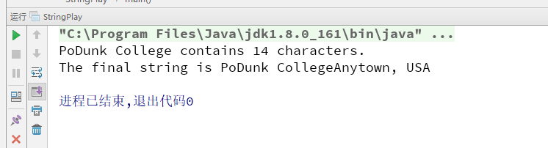
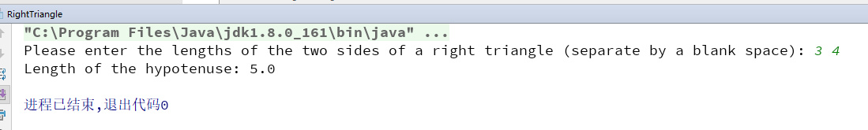
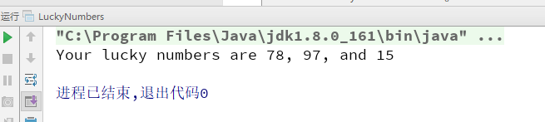
3) Answer questions

4)Error Analysis and Discussion

2 Working with Strings(Choose to do)
1) Source code list

2) Results data processing

3) Answer questions

4)Error Analysis and Discussion

3 Rolling Dice
1) Source code list
package chapter03;
import java.util.Random;
/**
* @Description:
* @Author: QiuGuanLin
* @Date: 2018/3/28 16:47
*/
public class Rolling_Dice {
public static void main(String[] args) {
Random generator = new Random();
int lucky1, lucky2, result;
lucky1 = generator.nextInt(6) + 1;
lucky2 = generator.nextInt(6) + 1;
result = lucky1 + lucky2;
System.out.println("俩骰子的点数分别为 " + lucky1 + ", " + lucky2
+ ", 点数之和为 " + result);
}
}

2) Results data processing
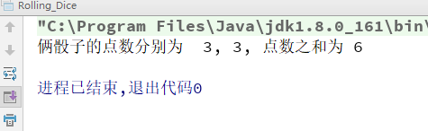

3) Answer questions

4)Error Analysis and Discussion

4 Computing Distance
1) Source code list
package chapter03;
import java.util.Scanner;
/**
* @Description:
* @Author: QiuGuanLin
* @Date: 2018/3/28 17:01
*/
public class Distance {
public static void main(String[] args) {
double x1, y1, x2, y2; // coordinates of two points
double distance; // distance between the points
Scanner scan = new Scanner(System.in);
// Read in the two points
System.out.print("Enter the coordinates of the first point " +
"(put a space between them): ");
x1 = scan.nextDouble();
y1 = scan.nextDouble();
System.out.print("Enter the coordinates of the second point: ");
x2 = scan.nextDouble();
y2 = scan.nextDouble();
// Compute the distanc
// Print out the answer
distance = Math.sqrt(Math.pow((x1 - x2), 2.0) + Math.pow((y1 - y2), 2.0));
System.out.print("The distance of two point is : " + distance);
}
}

2) Results data processing
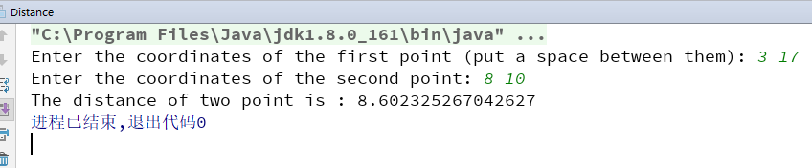

3) Answer questions

4)Error Analysis and Discussion

5 Formatting Output
1) Source code list
package chapter03;
import java.text.DecimalFormat;
import java.text.NumberFormat;
import java.util.Scanner;
/**
* @Description:
* @Author: QiuGuanLin
* @Date: 2018/3/28 17:04
*/
public class Deli {
// ---------------------------------------------------
// main reads in the price per pound of a deli item
// and number of ounces of a deli item then computes
// the total price and prints a "label" for the item
// --------------------------------------------------
public static void main(String[] args) {
final double OUNCES_PER_POUND = 16.0;
double pricePerPound; // price per pound
double weightOunces; // weight in ounces
double weight; // weight in pounds
double totalPrice; // total price for the item
Scanner scan = new Scanner(System.in);
// Declare money as a NumberFormat object and use the getCurrencyInstance method to assign it a value
// 将货币声明为NumberFormat对象，并使用getCurrencyInstance方法为其赋值
NumberFormat money = NumberFormat.getCurrencyInstance();
// Declare fmt as a DecimalFormat object and instantiate
// 将fmt声明为十进制格式对象并实例化
// it to format numbers with at least one digit to the left of the
// decimal and the fractional part rounded to two digits.
// 它可以在小数点左边至少有一位数的数字，小数部分四舍五入为两位数。
DecimalFormat fmt = new DecimalFormat("0.##");
// prompt the user and read in each input
// 提示用户并阅读每个输入
System.out.println("Welcome to the CS Deli!!\n ");
System.out.print("Enter the price per pound of your item: ");
pricePerPound = scan.nextDouble();
System.out.print("Enter the weight (ounces): ");
weightOunces = scan.nextDouble();
// Convert ounces to pounds and compute the total price
// 将盎司换算成磅并计算总价格
weight = weightOunces / OUNCES_PER_POUND;
totalPrice = pricePerPound * weight;
// Print the label using the formatting objects
// fmt for the weight in pounds and money for the prices
System.out.println("***** CS Deli *****\n ");
System.out.println("Unit Price: " + money.format(pricePerPound) + " per pound ");
System.out.println(" Weight: " + fmt.format(weight) + " pounds \n");
System.out.println("TOTAL: " + money.format(totalPrice));
}
}

2) Results data processing
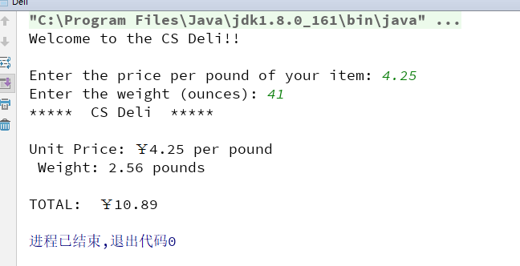

3) Answer questions

4)Error Analysis and Discussion

6 Playing with Cards
1) Source code list

package chapter03;
/**
* @Description:
* @Author: QiuGuanLin
* @Date: 2018/3/28 13:21
*/
public class RankTest {
enum Rank {
ace, two, three, four, five, six, seven, eight, nine, ten, jack, queen, king
}
public static void main(String[] args) {
Rank highCard = Rank.ace;
Rank faceCard = Rank.jack;
System.out.println("A blackjack hand: " + highCard + " and " + faceCard);
Rank card1 = Rank.two;
Rank card2 = Rank.three;
// 默认情况下，枚举类会给所有的枚举变量一个默认的次序，该次序从0开始，类似于数组的下标。
// 而.ordinal()方法就是获取这个次序（或者说下标）
// 所以结尾还要加 1 才能代表卡片的数字
int card1Val = card1.ordinal() + 1;
int card2Val = card2.ordinal() + 1;
System.out.println("A two card hand: " + card1 + " " + card2);
System.out.println("Hand value: " + (card1Val + card2Val));
}
}

2) Results data processing
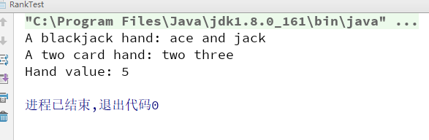

3) Answer questions

4)Error Analysis and Discussion

7 Experimenting with the Integer Class(Choose to do)
1) Source code list

2) Results data processing

3) Answer questions

4)Error Analysis and Discussion

8 Nested Panels
1) Source code list
package chapter03;
import javax.swing.*;
import java.awt.*;
/**
* @Description: Demonstrates a basic component hierarchy.
* @Author: QiuGuanLin
* @Date: 2018/3/28 21:32
*/
public class NestedPanels {
public static void main(String[] args) {
JFrame frame = new JFrame("Nested Panels");
frame.setDefaultCloseOperation(JFrame.EXIT_ON_CLOSE);
// Set up first subpanel
// 实例化一个Jpanel容器
JPanel subPanel1 = new JPanel();
// 设置宽高
subPanel1.setPreferredSize(new Dimension(150, 100));
// 设置背景样式
subPanel1.setBackground(Color.green);
// 声明一个JLabel标签 用来放文字
JLabel label1 = new JLabel("One");
// 将JLabel标签 添加到 JPanel类型的subPanel1里
subPanel1.add(label1);
// Set up second subpanel
JPanel subPanel2 = new JPanel();
subPanel2.setPreferredSize(new Dimension(150, 100));
subPanel2.setBackground(Color.red);
JLabel label2 = new JLabel("Two");
subPanel2.add(label2);
// Set up primary panel 声明一个基本面板
JPanel primary = new JPanel();
// 设置基本面板的背景颜色
primary.setBackground(Color.blue);
// 设置第三个子面板
JPanel subPanel3 = new JPanel();
subPanel3.setPreferredSize(new Dimension(300, 100));
subPanel3.setBackground(Color.orange);
JLabel label3 = new JLabel("Three");
subPanel3.add(label3);
// 将该子面板添加到基本面板
// primary.add(subPanel3);
// 现在增加另一个背景为蓝色,
// 大小为320*20的面板,
// 添加一个显示"My Panels"的label到该面板中
JPanel primary2 = new JPanel();
primary2.setPreferredSize(new Dimension(320, 20));
primary2.setBackground(Color.blue);
primary2.add(new JLabel("My Panels"));
primary.add(primary2);
// 往基本面板里加定义好的JPanel容器
primary.add(subPanel1);
primary.add(subPanel2);
//先获得JFrame的内容面板，在添加primary
frame.getContentPane().add(primary);
// frame.pack()函数的作用根据窗口里面的布局及组件的preferedSize来确定frame的最佳大小
frame.pack();
//设置frame可见
frame.setVisible(true);
// 将面板大小设置为320*260
frame.setSize(320, 260);
}
}

2) Results data processing
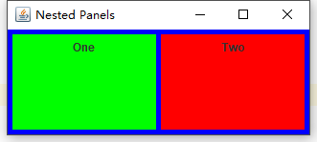
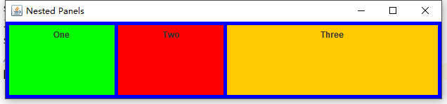

设置大小为320*260后
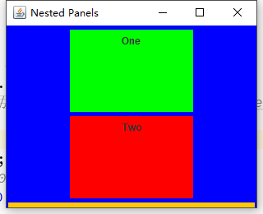

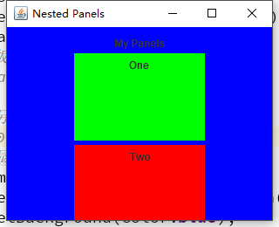
3) Answer questions

4)Error Analysis and Discussion

